STATIC CODE ANALYSIS USING SONARQUBE
Simple Java Program — Lab Implementation Manual
- Name: Vineet Gajjelli
- Rollno:2420030375
- ExpNo-8

Aim
To perform static code analysis on a simple Java program using SonarQube and identify code quality issues such as bugs, code smells, vulnerabilities, and maintainability problems.

Objectives
After completing this experiment, you should be able to: configure Java/Maven; start SonarQube; create a Maven Java project; create an analysis token; run the Sonar scanner; inspect bugs, vulnerabilities, code smells and maintainability measures; and explain the Quality Gate.

Requirements
Item | Recommended / Example
Operating System | macOS / Windows / Linux
Java | JDK 17 or a version supported by your selected SonarQube release
Build tool | Apache Maven 3.x
SonarQube | SonarQube Server running locally
Browser | Chrome / Safari / Firefox
Optional | Docker Desktop

Theory
Static code analysis examines source code without executing the application and detects patterns associated with defects, security weaknesses, duplication, poor maintainability, and other quality problems.
SonarQube is a code quality and security analysis platform. A scanner analyzes the project and sends the report to the SonarQube Server, where results appear in the project dashboard.
Java source code → Maven build → SonarScanner for Maven → SonarQube Server → Project dashboard → Is

Create the Java Project
Open Terminal and run:
mkdir -p ~/sonarqube-java-demo/src/main/java/com/example cd ~/sonarqube-java-demo Create pom.xml:
<project xmlns="http://maven.apache.org/POM/4.0.0">
<modelVersion>4.0.0</modelVersion>
<groupId>com.example</groupId>
<artifactId>sample-java</artifactId>
<version>1.0</version>
<properties>
<maven.compiler.source>17</maven.compiler.source>
<maven.compiler.target>17</maven.compiler.target>
<project.build.sourceEncoding>UTF-8</project.build.sourceEncoding>
</properties>
</project>
Create src/main/java/com/example/QualityDemo.java:
package com.example;
public class QualityDemo { private static final String PASSWORD = "admin123";
public static void main(String[] args) { QualityDemo demo = new QualityDemo();
System.out.println(demo.calculateAverage(new int[]{10,20,30,40}));
System.out.println(demo.findUser(null)); }
public double calculateAverage(int[] values) { int total = 0; for (int i = 0; i <= values.length; i++) { total += values[i]; } return total / values.length; }
public String findUser(String name) { if (name == null) return "UNKNOWN"; if (name.equals("admin")) return "Administrator"; else return "User"; }
public void duplicatedLogic() { System.out.println("Start");
System.out.println("Start");
System.out.println("Start");
}
}

Check Java and Maven
java -version mvn -version
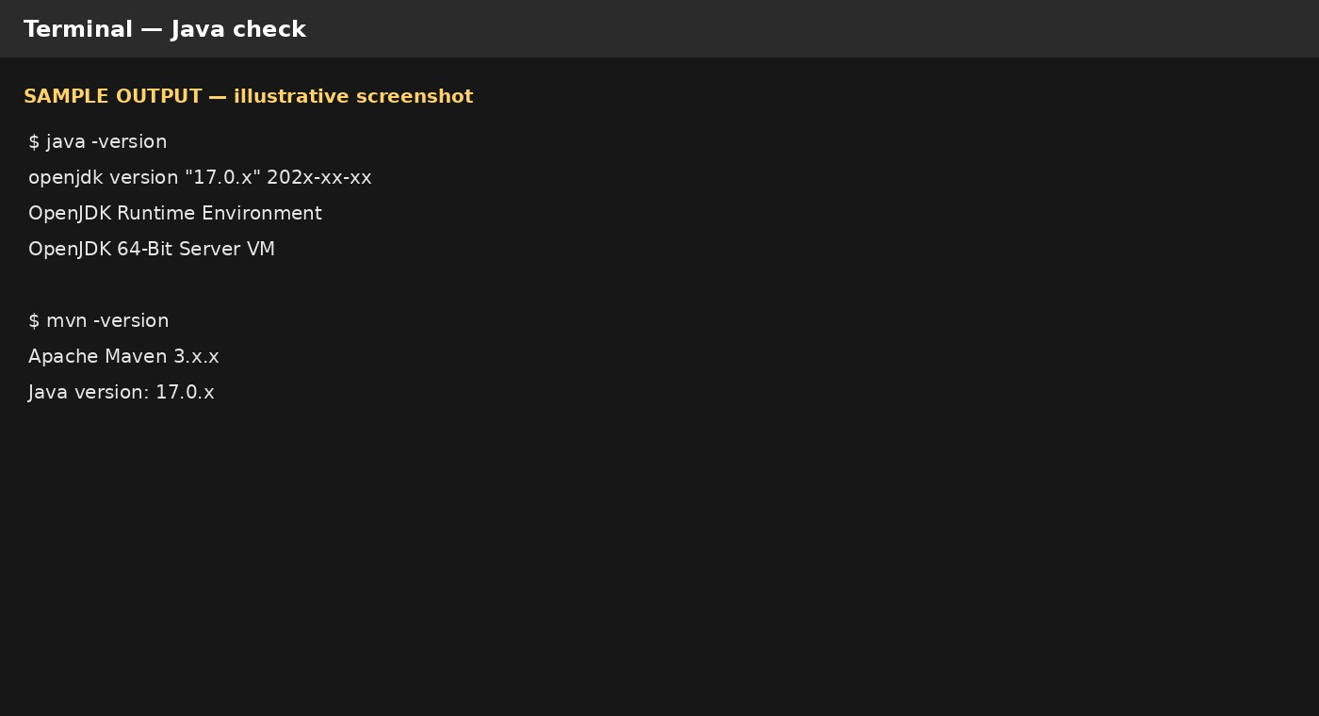
Figure 1. SAMPLE / ILLUSTRATIVE output. Capture your own environment screenshot.

Start SonarQube
With Docker Desktop running, use:
docker run -d --name sonarqube -p 9000:9000 sonarqube:community docker ps
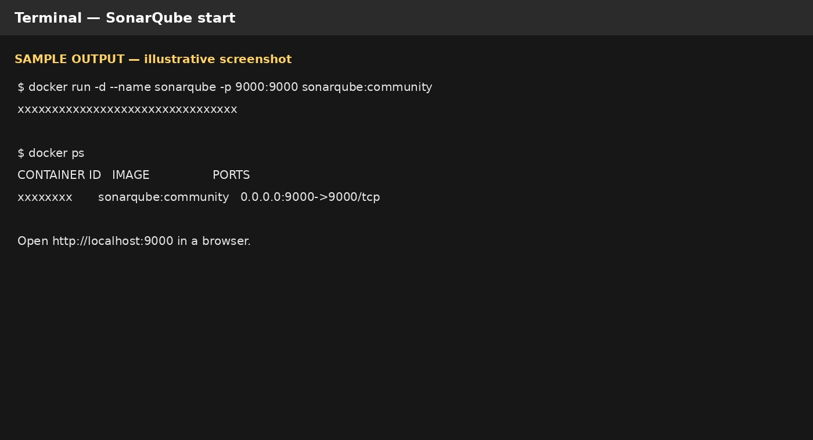
Figure 2. SAMPLE / ILLUSTRATIVE Docker output.

Open SonarQube and Create a Token
Open http://localhost:9000. Complete the sign-in/onboarding flow for your installation. Create an analysis token from the account/security settings and keep it private. Never commit the token to source control.

Run the Maven Analysis
cd ~/sonarqube-java-demo
mvn clean verify sonar:sonar \ -Dsonar.projectKey=sample-java \
-Dsonar.host.url=http://localhost:9000 \
-Dsonar.token=<YOUR_TOKEN>
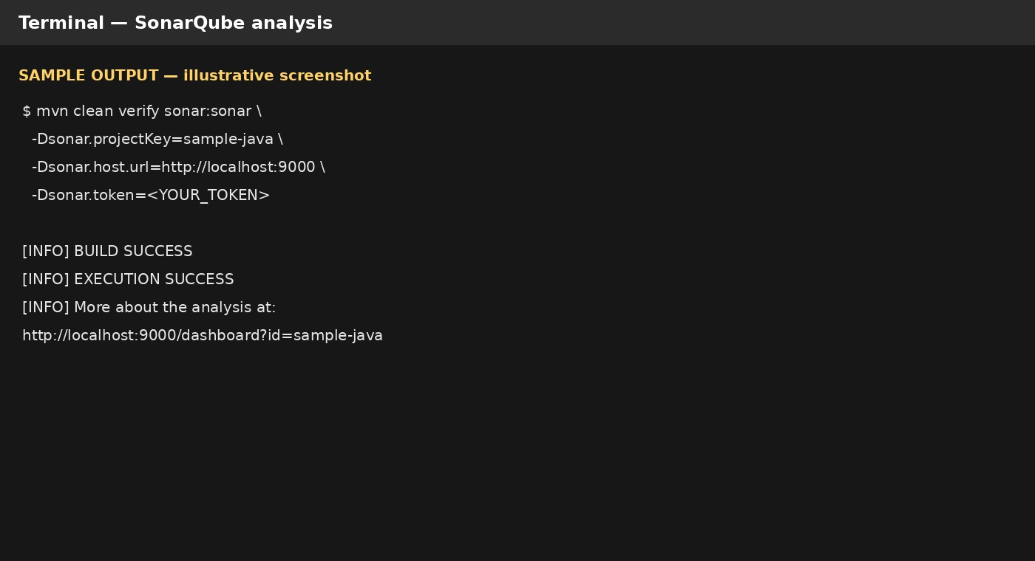
Figure 3. SAMPLE / ILLUSTRATIVE analysis output.

View the Analysis Results
Open the project dashboard in SonarQube after the scanner completes. The terminal log normally provides a dashboard URL.
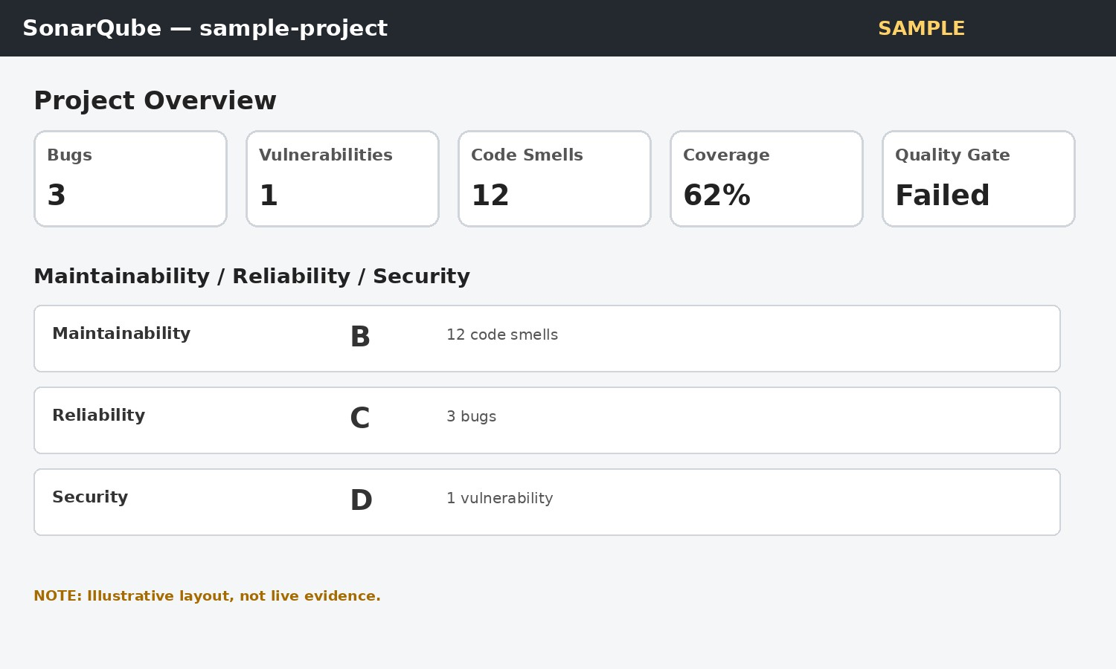
Figure 4. SAMPLE / ILLUSTRATIVE dashboard. Capture your actual dashboard for proof.

Identify the Reported Issues
Category | What to inspect | Example
Bugs | Defects that can cause incorrect behavior | i <= values.length
Vulnerabilities / Secu | ritySecurity-sensitive weaknesses | Hard-coded credential-like value
Code Smells | Maintainability/design problems | Unnecessary or repetitive structure
Quality Gate | Configured quality conditions | May fail if thresholds are exceeded

Explain the Results
Bug: a defect that can lead to incorrect behavior. Here, values[values.length] is outside the valid array range.
Code smell: a maintainability warning suggesting the code could be cleaner, simpler, or easier to change. A smell is not automatically a runtime bug.
Security finding: a rule violation that can expose an application to security risk; exact classification depends on the active rules and SonarQube version.
Maintainability: an indication of how difficult the code is expected to be to understand, modify, and maintain.

Corrective Actions
for (int i = 0; i < values.length; i++) { total += values[i]; }
// Example: do not hard-code credentials
String password = System.getenv("APP_PASSWORD");
Run the analysis again after fixes and compare the issue list and Quality Gate.

Expected Result
The Java project is successfully analyzed by SonarQube. The dashboard displays code-quality measures and identifies issues according to the active rules. The student can locate individual issues, explain their impact, and apply fixes.

Conclusion
SonarQube provides automated static analysis that helps identify defects, security concerns, code smells, and maintainability problems. The experiment demonstrates the complete flow from Java source code and Maven through scanner execution to dashboard-based inspection and remediation.

